Microsoft Dynamics User Guide

April 2018

Version

**Microsoft Dynamics**

Document Revisions

|  |  |  |
| --- | --- | --- |
| Date | Version Number | Document Changes |
| 25/04/2018 | 1 | Final Version |
|  |  |  |
|  |  |  |
|  |  |  |
|  |  |  |
|  |  |  |
|  |  |  |
|  |  |  |
|  |  |  |

Table of Contents

1 Introduction 5

1.1 Scope and Purpose 5

1.2 Process Overview 5

2 [Process/WorkFlow 1] 6

2.1 [Sub-Process or Workflow Step 1] Example: Configure Connect to manage your work 6

2.1.1 [Procedures for Step 1] Example: To Log in to Connect: 6

2.1.2 [Procedures for Step 2]: 7

2.2 [Sub-Process or Workflow Step 2] Example: Asset Record Statuses 8

3 Appendices 9

4 Index 10

# Introduction

## Scope and Purpose

The product focuses mainly on Sales, Marketing, and Service (help desk) sectors, but Microsoft has been marketing Dynamics CRM as an CRM platform and has been encouraging partners to use its proprietary (.NET based) framework to customize it. It is part of the Microsoft Dynamics family of business applications.

This user guide points to content that will help power users and administrators configure Microsoft Dynamics 365 for Operations. This content will help users to configure the system to work smoothly and effectively for their organization and business.

## Process Overview

Microsoft Dynamics CRM is a customer relationship management software package developed by Microsoft, focusing on enhancing customer relationships for any organization.

It is one of the leading industry-standard CRM software available in market. The product focuses mainly on Sales, Marketing, and Customer Service sectors.

However Microsoft has been marketing Dynamics CRM as an XRM platform and has been encouraging partners to use its proprietary (.NET based) framework to customize it.

This topic points to content that will help power users and administrators configure Microsoft Dynamics 365 for Finance and Operations. This content will help them configure the system to work smoothly and effectively for your organization and business.

# [Process/Work-Flow 1]

Once you login and gain access to the CRM, you can begin making records.

Number systems are used to generate readable, unique identifiers for master data records and transaction records that require identifiers.

A master data record or transaction record that requires an identifier is referred to as a reference.

Before you can create new records for a reference, you must set up a number sequence and associate it with the reference.

## [Sub-Process or Workflow Step 1]

## Configure Connect to manage your work

Go to [http://portal.office.com](http://portal.office.com/).

### Procedures for Step 1

If you have a license for Dynamics Marketing, then you should see a link to it when you sign into [http://portal.office.com](http://portal.office.com/). If you don't see the Dynamics Marketing button there, then talk to your O365 admin and ask to be assigned a license.

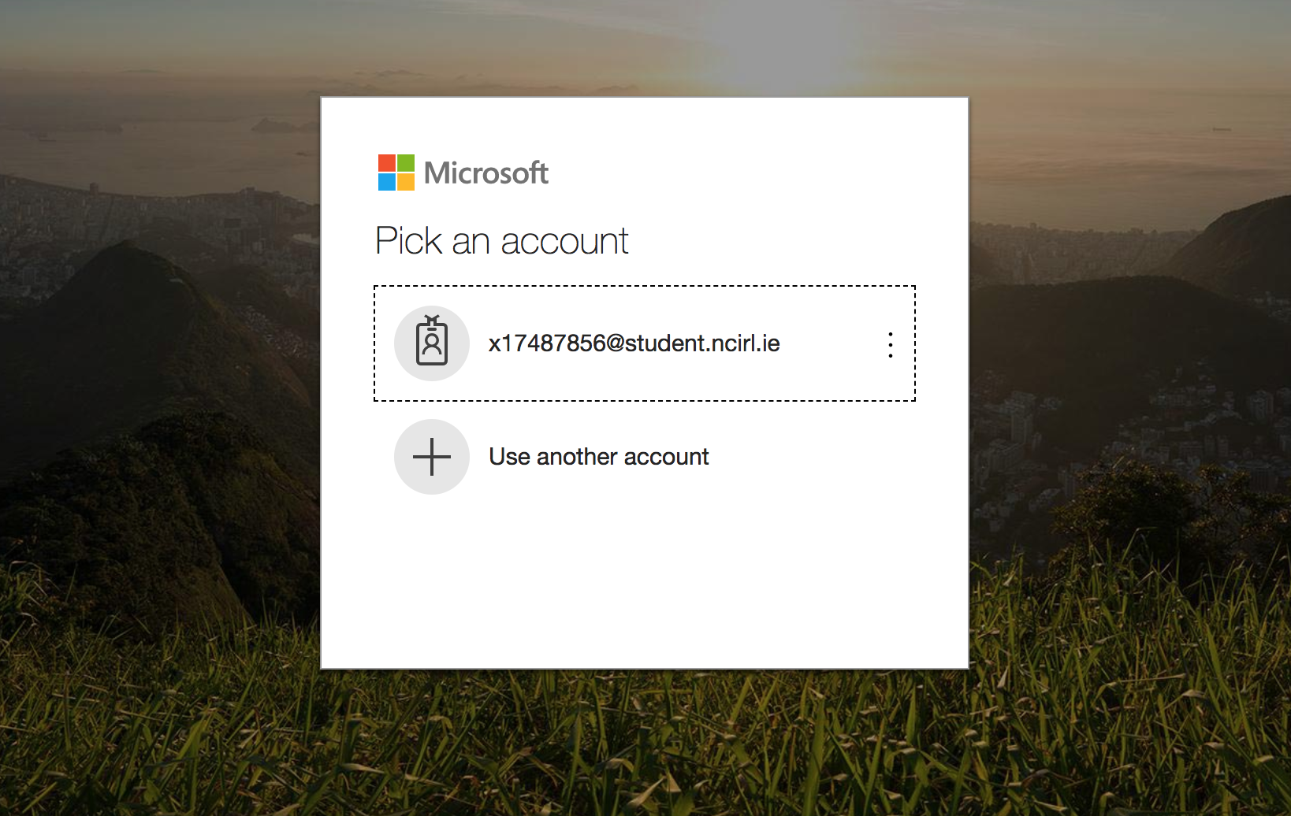

1. Sign in
2. If you don’t see MS dynamics, you should talk to your O365 admin and ask to be assigned a license.

NOTE: You will need an internet connection to access MS dynamics crm

### Procedures for Step 2:

* Once you are in to dynamics CRM.
* Views:
* Whenever you are looking at a list of data, it is always displayed in a grid view.  The grid views throughout Microsoft Dynamics 365 have common functionality, including:
* The ability to select one or more records to complete an action
* The ability to sort, filter, and search the data
* The ability to analyse the data with charts

By default, grids are in a **Read-Only** style.

Users also have the ability to use the Show As button in the command bar to toggle between editable or read-only grid styles.

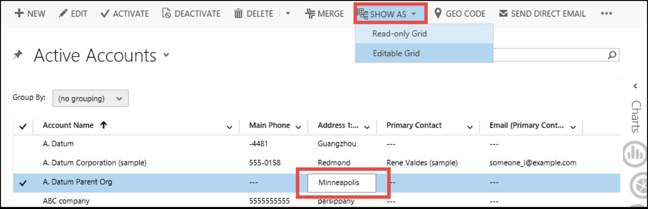

1. There are two categories for views; **System Views** and **Personal Views**.
2. System views are available for all users to use while a personal view is something that a user can create to filter and display the records to their own preferences.
3. Users can choose to share their personal views with other users or teams.

If you encounter issues not addressed by this user guide, please contact your account manager for additional support.

# Appendices

# Sharing Personal Views in Microsoft Dynamics CRM

One of the many fantastic features available to users (and most often used) in Microsoft Dynamics CRM is the ability to create saved, personal views with an advanced find to see a filtered list of records.

While your System Administrator does his or her best to create a set of system views (available to all users) they simply can’t predict all the views that each viewer will want see.  Personal Views are a great way for users to get a quick, simple custom view of a specific list of records and retain that view for future reference.

# Creating Document Templates for Dynamics CRM 2016

The new release of CRM offers a Document Generation tool which provides the flexibility for users to create predefined templates in Microsoft Word and Microsoft Excel. These template are easy to open with CRM data populated within the document.

